IOAI 2025 Individual Contest Day 2
Team Leaders Translation Version

Team Leaders must complete the form below, even if they don’t need translated documents.
Country Or Region | Rwanda
Number of Team Members （sample papers will be duplicated according to the number） | 4
How many pages in total (cover pages included) | 17

IOAI2025 Kurubuga-Icyiciro: Guhuza Agashusho k'ubwiherero

Icyitonderwa: Nyamuneka "winjire" mu marushanwa mbere. Noneho, urashobora gushiraho dataset kuri GPU. Bitabaye ibyo, notebook ishobora guhura nikosa kuko ntishobora kugera kuri dataset kugeza igihe winjiye mumarushanwa.

1. Ibisobanuro by'ibibazo
Iki kibazo cyiribanda kukuba watraininga model yiga isano iri hagati yishusho yubwiherero bwumugabo nigitsina gore ziri kubwiherero bumwe . Ukurikije training data, urasabwa gukora model yisanisha nayo, uhawe ishusho mukibazo, shaka genzi yayo bidahuje ibitsina (urugero, huza icon ya cropped image yumugabo ni shusho yumugore bihura ya orginal), ushingiye ko amashusho yombi ava mubwiherero bumwe .
Urugero, kwishusho yabajijwe (urugero, igishushanyo cyumugabo mugishusho cyaciwe) cyerekanwe hepfo mugishushanyo cya 1, mugenzi wacyo uhwanye nacyo yerekanwe mugishushanyo cya 2 (ni ukuvuga igishushanyo cyumugore mumashusho yumwimerere kiva mubwiherero bumwe).
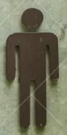 | 

2. Dataset
(1) Training set:
Byakozwe kugirango u tarininge model. Uko directory iteye:
train /
├── crop / # Udushushanyo twakaswe
│ ├── igitsina gore / 1.png, 2.png, ...
│ └── umugabo /
└── orign / # Original icons
├── igitsina gore /
└── umugabo /
Buri subfolder irimo amashusho yitiriwe kuva 1.png kugeza 82.png , aho umubare werekana ID. Kuri buri bwiherero, hari amashusho ane (menya ko amashusho ane yo mu bwiherero bumwe azagabana id imwe kuri subfolders zose uko ari enye):
- crop / igitsina gore / i.png → Agashusho k'umugore
- crop / igitsina gabo / i.png → Igishushanyo cyumugabo
- crop / igitsina gore / i.png icon Ishusho originale y’umugore
- crop / umugabo / i.png icon Igishusho originale y’umugabo
(2) Validation Set and Test Set:
Haba validation set (test_a) cyangwa test set (test_b) birimo subfolders ebyiri:
test_a / .​​​
​​​
​​​
- ikibazo / : amashusho yaciwe agomba guhuzwa.
- ububiko / : ibishushanyo byumwimerere.
- Menya ko:
  - Filenames zo muri query na gallery zabazwe zigacangwa ntabwo ziri kumurongo kimwe nko muri training split, ntabwo aribyo kwishyingikiriza kuri ids
  - Kuri buri gishushanyo cyakuwe mubibazo / hari ebyiri zazo za orginale muri gallery/ (umugabo umwe, umugore umwe kuva mubwiherero bumwe), bivuze$\text{len}(\text{gallery})=2*\text{len}(\text{query})$
- Amashusho yose ari mubwoko bwa .png .
- Validation set ifite amashusho 10 mubibazo / mububiko, kandi test dataset yo ifite amashusho 30 mubibazo / mububiko.

3. Inshingano
Kuri buri shusho query / folder, yikorere prediction muri gallery / kuburyo:
- Ari mubitsina bitandukanye , kandi
- Iva mu bwiherero bumwe
Uku guhuza kugomba gukorwa ukoresheje model yawe .

4. Submission
Ugomba gutanga notebook yitwa submission.ipynb , igomba kuba irimo:
- Model training process (ukoresheje gari ya moshi / amakuru)
- Matchng process for both test sets ( test_a / na test_b / )
- The notebook must output two.npy :
submission_a.npy # Guhuza ibisubizo byo kwemeza (test_a).
submission_b.npy # Guhuza ibisubizo kubizamini (test_b).
Buri fayili ya npy numurongo umwe-munini hamwe nubunini bungana numubare wibibazo, kandi buri gaciro muri array gahuye nindangamuntu yishusho muri gallery.
Urugero, icyifuzo kimwe submission_a.npy gishobora kugaragara nkiki:
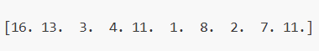
Urashobora kandi kubona urugero rwibisohoka muburyo bwa baseline.ipynb .

5. Amanota
- Niba gutanga birangiye mugihe ntarengwa, amanota abarwa nka:
$$\text{Score}=\frac{\text{Number of correct matches}}{\text{Total queries}} \text{(1)}$$
- izaba umubare ureremba hagati $0.0$na $1.0$(harimo).
- Ibyatanzwe birenze igihe bizakira amanota 0 .

6. Ibyingenzi n'amahugurwa
- Ibyingenzi biri murwego baseline.ipynb .
- Dataset iri training set .

7. Ibisabwa
- Umubare ntarengwa wo gutanga: inshuro 15 . Gusa ibyatanzwe neza (ni ukuvuga, abahawe amanota kurutonde rwubuyobozi A) bazabarwa kugeza kumipaka yatanzwe.
- Testing environment restrictions: Test machine izakoresha notebook yawe muminota 15 . Niba igihe cyo gukora kirenze iminota 15 , sisitemu izahagarika kandi iguhe feedback "timeout" cyangwa "Failed".
- Data and model submission: Muri iki gikorwa, abitabiriye amahugurwa bashobora gutanga notebook gusa kandi ntibashobora gutanga imibare yashyizweho cyangwa .pth dosiye yakozwe nabo ubwabo. Nyamuneka reba hejuru iburyo kugirango ukureho dataset yabanje.
- 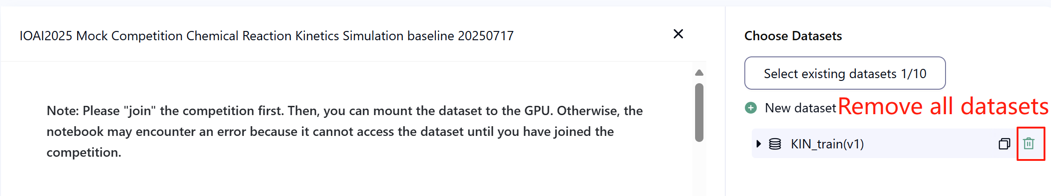
- Network: For the on-site stage, imashini ntishobora gukoresha enterineti. Muyandi magambo, gukuramo amategeko nka 'pip' na 'conda' cyangwa kugerageza guhamagara API ntabwo bizakora.
- Pretrained model: Muri iki gikorwa, dutanga gusa Clip moderi muri dataset. Urashobora kuyikoresha nkuko biri muri baseline.ipynb . Iyindi moderi yabanje gutozwa irashobora gukoreshwa muriki gikorwa mugihe ishobora gutumizwa neza nta guhuza imiyoboro no gukuramo. Ubu butumwa bivuze ko Bohrium idashobora kwemeza gukuraho moderi zose zateganijwe mu ishusho ya Python mugihe ushyizeho paki, mugihe ubonye zimwe zingirakamaro, urashobora kuzikoresha.

8. Icyitonderwa
- Ni ayahe manota afite akamaro: Abahatana barashobora guhitamo ibisubizo 2 byo gutanga ibisubizo (√ - byatoranijwe ， □ - ntabwo byatoranijwe). Amanota mbere yo guhuriza hamwe iki gikorwa azagenwa n amanota yo hejuru kuri Leaderboard B mubyifuzo bibiri byatoranijwe. Izindi manza zo kubara amanota: nyamuneka reba Umugereka wa Platform Mechanism hamwe nimbogamizi kumarushanwa ya buri muntu & GAITE .
- 
- Uburyo bwo guhangana n'ibidasobanutse: Iyo habaye amakimbirane hagati yo gusobanura inshingano no gushyiraho amahugurwa, kwemeza no gushiraho ibizamini, dataset izubahirizwa mbere, kandi dataset ntizahinduka mugihe cyamarushanwa.
- abacontestants bashobora kubona leaderboard A gusa mugihe cyamarushanwa kandi ntibashobora kubona leaderboard B. amanota yanyuma azabarwa gusa hashingiwe kumanota yo kuri leaderboard B.
- Amanota menshi hashingiwe kuri scientific committe kuriyi nshingano ni $0.90$ kuri leaderboard B, aya manota akoreshwa muguhuza amanota.
- Amanota y'ibanze hashingiwe kuri scientific committe ni $0.77$ kuri leaderboard B, aya manota akoreshwa muguhuza amanota.

IOAI2025 Kuri Stage Icyiciro: Kwemeza Ibishushanyo bya kera

Icyitonderwa: Nyamuneka "winjire" mu marushanwa mbere. Noneho, urashobora gushiraho dataset kuri GPU. Bitabaye ibyo, ikaye irashobora guhura nikosa kuko ntishobora kugera kuri dataset kugeza igihe winjiye mumarushanwa.

1. Ibisobanuro by'ibibazo
Wize Artificial Intelligence igihe kitari gito. Inshuti ishaje ya so, uzwi cyane mu bucukumbuzi bw'ibyataburuwe mu matongo akaba anenga ibihangano, yumvise ibi maze agusaba ubufasha. Ugomba gukora algorithm ishobora gutondekanya ibishushanyo bya kera nkibice byukuri cyangwa byasubiwemo.
Kuberako kwemeza bihenze, itsinda ryubushakashatsi ryabonye gusa ibirango byukuri kubice bito byamashusho. Sample nyinshi, ukuri ntikumenyekana. Birazwi ko ibishushanyo bihuza patterns zitadukanye. Ufite inshingano zo gukoresha ingero zose zishoboka - harimo izifite ibirango bitazwi – ugakora model 3yo gutondekanya ukuri kw'ibishushanyo bya kera.

2. Dataset
Dataset igizwe namahugurwa yashizweho, kwemeza no gushiraho ikizamini, buri kimwe gifite 500 byigenga.
- Training set( training_set.csv ) :
  - Inkingi eshanu zambere zerekana ibimenyetso bya digitale ya buri gishushanyo cya kera.
  - Inkingi ya gatandatu ikubiyemo ikirango: 1 kuri kweri, -1 kuri kopi, na 0 kubitazwi.
- Amahugurwa akoreshwa mugutoza icyitegererezo cyawe kandi urashobora kugerwaho no gukururwa mugihe cyamarushanwa.
- Validation set( validation_set.csv ) :
  - Ibi bisa nuburyo bwo guhugura gushiraho ariko ntibikubiyemo ikirango.
- Iyemezwa ryashyizweho rikoreshwa mukubara Ubuyobozi A amanota kandi ntabwo igerwaho mugihe cyamarushanwa.
- Test set ( test_set.csv ) :
  - Ibi bisa nuburyo bwo guhugura gushiraho ariko ntibikubiyemo ikirango.
- Ikizamini cyakoreshejwe mukubara amanota yubuyobozi B kandi ntigishobora kuboneka mugihe cyamarushanwa.

3. Task
Igikorwa cyawe nuguhugura icyitegererezo gikwiye gishobora guhanura ukuri kwishusho mubizamini, nubwo umubare munini wintangarugero utabigenewe.

4. Submission
Abanywanyi bakeneye gutanga ikaye ya dosiye yitwa submission.ipynb . Dosiye igomba gusohora zip dosiye yitwa submission.zip , igomba kuba irimo dosiye ebyiri zikurikira:
- kwitangaA.csv : Harimo icyitegererezo cyahanuwe cyerekana ibisubizo ibisubizo byemejwe, hamwe numurongo wose -1 cyangwa 1 kandi nta mutwe.
- kwitangaB.csv : Harimo icyitegererezo cyibiteganijwe cya label ibisubizo ku kizamini cyashyizweho, buri murongo ukaba -1 cyangwa 1 kandi nta mutwe.
Imashini yipimisha izasoma ibyatanzwe.zip hanyuma ubare amanota. Amadosiye yoherejwe agomba gukurikiza byimazeyo imiterere yavuzwe haruguru no kwita izina; bitabaye ibyo, sisitemu ntizashobora kuyisoma neza.
Ibisobanuro birambuye kubijyanye no gutanga byatanzwe mu ikaye y'ibanze. Abitabiriye amarushanwa barashishikarizwa kubohereza kugirango bayobore.

5. Amanota
Ibipimo byo gusuzuma bizashyirwa mubikorwa neza , bisobanurwa nkigipimo cyurugero rwahanuwe neza hejuru yumubare rusange wapimwe.

6. Baseline and Training set
- Ibyingenzi biri murwego rwibanze.ipynb .
- Dataset iri mumahugurwa yashizweho .

7. Ibisabwa
- Umubare ntarengwa wo gutanga: inshuro 15 . Gusa ibyatanzwe neza (ni ukuvuga, abahawe amanota kurutonde rwubuyobozi A) bazabarwa kugeza kumipaka yatanzwe.
- Kugerageza kubuza ibidukikije: Imashini yikizamini izakoresha Ikaye yawe muminota 10 . Niba igihe cyo gukora kirenze iminota 10 , sisitemu izahagarara ku gahato kandi isubize ibitekerezo bya "Igihe cyateganijwe" cyangwa "Byatsinzwe".
- Ibyatanzwe hamwe nicyitegererezo: Muri iki gikorwa, abahatana barashobora gutanga Ikaye gusa kandi ntibashobora gutanga imibare yose yashizwemo cyangwa dosiye .pth yakozwe nabo ubwabo. Nyamuneka reba inguni igororotse kugirango ukureho dataset yabanje.
- 
- Umuyoboro: Kubireba urubuga, imashini yipimisha ntishobora guhuza na enterineti. Muyandi magambo, gukuramo amategeko nka 'pip' na 'conda' cyangwa kugerageza guhamagara API ntabwo bizakora.
- Icyitegererezo cyateganijwe: Moderi yose yabanje gutozwa irashobora gukoreshwa muriki gikorwa mugihe ishobora gutumizwa neza nta guhuza imiyoboro no gukuramo. Ubu butumwa bivuze ko Bohrium idashobora kwemeza gukuraho moderi zose zabigenewe mu ishusho ya Python mugihe ushyira paki, mugihe ubonye zimwe zingirakamaro, urashobora kuzikoresha.

8. Precautions
- Ni ayahe manota afite akamaro: Abahatana barashobora guhitamo ibisubizo 2 byo gutanga ibisubizo (√ - byatoranijwe ， □ - ntabwo byatoranijwe). Amanota mbere yo guhuriza hamwe iki gikorwa azagenwa n amanota yo hejuru kurutonde rwabayobozi B mubyifuzo bibiri byatoranijwe. Izindi manza zo kubara amanota: nyamuneka reba Umugereka wa Platform Mechanism hamwe nimbogamizi kumarushanwa ya buri muntu & GAITE .
- 
- Uburyo bwo guhangana n'ibidasobanutse: Iyo habaye amakimbirane hagati yo gusobanura inshingano no gushyiraho amahugurwa, kwemeza no gushiraho ibizamini, dataset izubahirizwa mbere, kandi dataset ntizahinduka mugihe cyamarushanwa.
- Abanywanyi barashobora kubona Ubuyobozi A gusa mugihe cyamarushanwa kandi ntibashobora kubona Ubuyobozi B. B. amanota yanyuma azabarwa gusa hashingiwe kumanota mubuyobozi B.
- Amanota menshi na komite yubumenyi kuriyi nshingano ni 0,98 muri Leaderboard B, aya manota akoreshwa muguhuza amanota.
- Amanota y'ibanze na komite ishinzwe ubumenyi kuriyi nshingano ni 0.46 muri Leaderboard B, aya manota akoreshwa muguhuza amanota.

IOAI2025 Kuri Stage Icyiciro: Ikibazo Cyiza cya Pixel

Icyitonderwa: Nyamuneka "winjire" mu marushanwa mbere. Noneho, urashobora gushiraho dataset kuri GPU. Bitabaye ibyo, ikaye irashobora guhura nikosa kuko ntishobora kugera kuri dataset kugeza igihe winjiye mumarushanwa.

1. Ibisobanuro by'ibibazo
Uri umunyeshuri mubuzima bwibinyabuzima, ukora kumushinga wubushakashatsi bwibanze muri Starr Park Research Centre. Itsinda ryanyu ryohereje imitego ya kamera ibihumbi kugirango ibashe gufata species zaza mubinyabuzima zitazwi. Nyamara, enterineti ya satellite ihuza uturere twa kure ifite bandwidth nke cyane. Akazi kawe nukwandika code igaragaza pigiseli zingenzi muri buri foto yinyamanswa kugirango amakuru yingenzi abe ariyo yoherezwa kubiro bikuru.
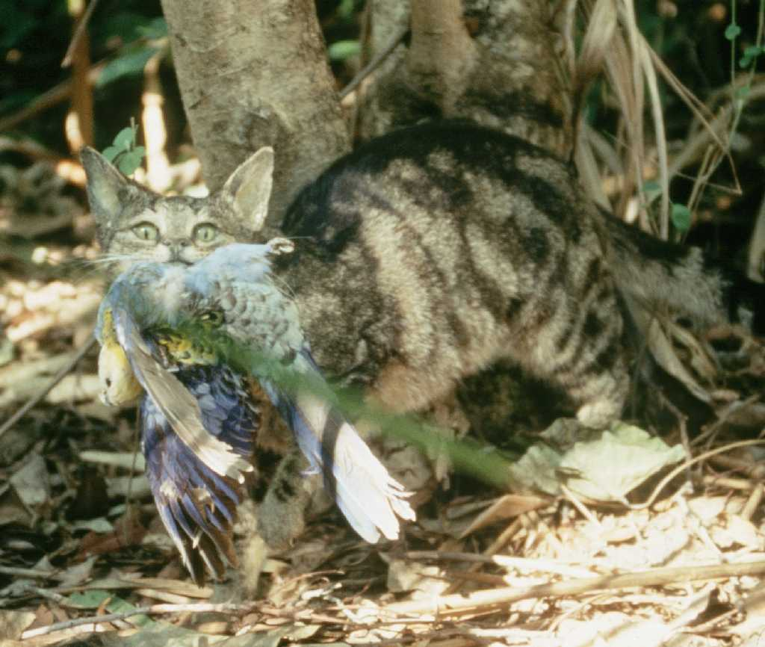

2. Dataset
Dataset igizwe namahugurwa hamwe nibizamini. Datasets yapakishijwe ukoresheje umutwaro_ku_disk , kandi uri muburyo bwa datasets . Ibizamini ntabwo bigaragara kubanywanyi.
Muri dataset hari imirima ikurikira:
- ishusho : ishusho ni RGB yuzuye amashusho yamabara muburyo bwa PIL, ubunini bwa buri shusho ni (224, 224)
- izina : ikirango cyubwoko bwinyamaswa
- idx : ibiranga byihariye bikoreshwa mugukurikirana inyandiko.
1. Gushiraho Amahugurwa ( Ububiko_dataset Ububiko) :
  - Amahugurwa akoreshwa mugutoza icyitegererezo cyawe / gukora igeragezwa kuri kandi urashobora kugerwaho no gukururwa mugihe cyamarushanwa.
  - Hano hari amashusho 700 murwego rwo guhugura.
2. Gushiraho Ikizamini ( ububiko bwa test_dataset ) :
  - Ibi bikurikiza imiterere imwe namahugurwa yashizweho ariko ntabwo arimo izina ryumwanya.
  - Hano hari amashusho 698 mugupima ing , yari yatandukanijwe mubice 2 byo kwipimisha ku kigereranyo cya 3: 7, ni ukuvuga 30% yamakuru yakoreshwa mukubara amanota yubuyobozi A amanota, andi makuru 70% yakoreshwa mukubara amanota yubuyobozi B.
  - Ikizamini cyo kwipimisha gikoreshwa mukubara Ikibaho Ubuyobozi A amanota hamwe nubuyobozi B B amanota kandi ntibishobora kuboneka mugihe cyamarushanwa. Abanywanyi barashobora kubona ibisubizo kurubuyobozi A, ariko ntibashobora kubona ibisubizo kurutonde rwabayobozi B. Amanota yanyuma yabarwa ukoresheje Ubuyobozi B gusa. Ibice byubuyobozi bwa A hamwe nubuyobozi B biratandukanye rwose.

3. Task
Uhabwa dataset yifoto yinyamanswa hamwe na CLIP yerekana ishobora gukora zero-shusho yubwoko bwinyamaswa. Kugirango ubungabunge umurongo mugari, ugomba kugumana byibuze 6.25% ya pigiseli ya buri shusho, mugihe ukomeza ibyiciro neza nkuko bishoboka.
By'umwihariko, umurimo wawe ni ugusubiza mask imwe y'urukiramende kuri buri shusho, ikubiyemo agace kamwe k'urukiramende rwerekana agace ugomba kubika. Buri mask isobanurwa nuburyo bubiri bwo guhuza: imwe kumurongo wo hejuru-ibumoso naho iyindi-iburyo-iburyo bwurukiramende. Hano hepfo ni ishusho yerekana uko ishusho yaba imeze nyuma yo gukoresha mask y'urukiramende ukoresheje inzira uhereye kumurongo:
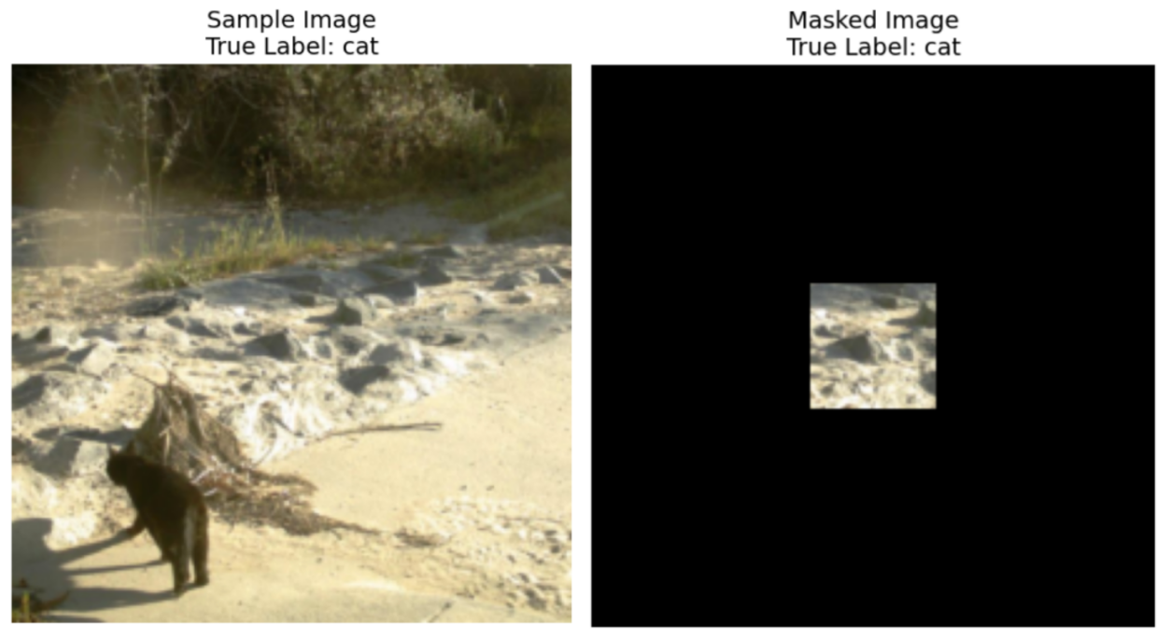
Guhuza Amasezerano:
- Hejuru-ibumoso inguni ihuza ( pigiseli kuriyi myanya iri muri mask)
- Hasi-iburyo inguni ihuza ( pigiseli kuriyi myanya ntabwo yashyizwe muri mask)
Kurugero, niba ugaragaje imirongo ((10, 20), (15, 25)) , mask izaba ikubiyemo pigiseli kuva kumurongo wa 10 kugeza 14 (harimo) hamwe ninkingi 20 kugeza 24 (ikubiyemo), kubuso bwa pigiseli 25.
Nkurugero, niba ingano yishusho ari 3x3 kandi twashakaga kugumana gusa pigiseli yo hejuru-iburyo dukoresheje imirongo ((0, 2), (1, 3)) , ibisubizo bya binini byombi byaba:
[[0, 0, 1],
[0, 0, 0],
[0, 0, 0]]
Hano hepfo ni incamake y'ibisabwa kuri masike yawe:
- Subiza mask imwe y'urukiramende rwasobanuwe na coordinate tuples: ((hejuru, ibumoso), (hepfo, iburyo))
- Hejuru-ibumoso inguni ihuza ibice, hepfo-iburyo inguni yihariye
- Mask y'urukiramende igomba gutwikira hafi 6.25% ya pigiseli yumwimerere (byibuze 93,75% yo kugabanya pigiseli yumwimerere)
- Amashusho yose afite ubunini (224, 224), bityo guhuza indangagaciro bigomba kuba murwego [0, 224]
Amashusho yaba masike ukoresheje mask wakoze, hanze yurukiramende rwuzuye, pigiseli zose hanze yurukiramende rwasizwe izasimbuzwa indangagaciro za RGB (0, 0, 0) (umukara). Igishusho gipfundikijwe noneho kizanyuzwa muri moderi ya CLIP mugihe cyo gusuzuma, kandi inshingano zawe nugukomeza gushyira muburyo bwa moderi ya CLIP kuri aya mashusho yipfutse hejuru bishoboka. Iyindi nyigisho yongeweho mubyiciro kugirango ishyirwe mubikorwa kugirango umenye neza ko ishusho yawe yipfunditse igumana amakuru yingirakamaro kubashakashatsi bagarutse ku cyicaro gikuru cya Starr. Kurugero rero, niba ishusho yawe idafite amakuru yinyamanswa, icyitegererezo kizahanura abandi cyiciro aho guhanura inyamaswa zidasanzwe kandi ufite amahirwe yo kuyikosora.
Ugomba gukorana gusa na moderi ya CLIP yatanzwe na dataset. Nkwibutse, CLIP itanga ishusho yinyandiko nishusho, kandi irashobora kubara amanota asa hagati yabo. Niba rero ufite ibyiciro icumi byinyamanswa, CLIP irashobora kureba ishusho yatanzwe hanyuma ugahitamo inyandiko (class) yegereye ishusho.
Kugirango umenye neza ko igisubizo cyawe cyakemura urujya n'uruza rwamashusho yikigo cyubushakashatsi, code yawe igomba gukorera MUMUNSI 8 MINUTES kumashusho 698 mumibare yikizamini . Birasabwa ko wapima igisubizo cyawe kumahugurwa yashizweho mbere, arimo amashusho 700, kugirango wumve igihe igisubizo cyawe gifata (igeragezwa ryogutwara igihe gito kubera gupakira dataset).

4. Submission
Abanywanyi bakeneye gutanga ikaye ya dosiye yitwa submission.ipynb . Idosiye igomba gusohora dosiye .jsonl yitwa submission.jsonl , ikubiyemo masike yose yakozwe kugirango dataset igabanuke. Buri mask mugutanga.jsonl dosiye igomba kubikwa nka tuple yibice bibiri bihuza: ((hejuru, ibumoso), (hepfo, iburyo)) , aho hejuru-ibumoso burimo kandi hepfo-iburyo hari umwihariko.
Abanywanyi ntibakeneye gutandukanya ibizamini mubuyobozi bwa A hamwe nubuyobozi B, imashini isuzuma izasoma ibyatanzwe.jsonl hanyuma ihite ibara amanota kubuyobozi bwa A hamwe nubuyobozi B bushingiye kubisubizo byavuzwe hamwe nibirango nyabyo.
Amadosiye yoherejwe agomba gukurikiza byimazeyo imiterere yavuzwe haruguru no kwita izina; bitabaye ibyo, sisitemu ntizashobora kuyisoma neza.

5. Amanota
Ibipimo byo gusuzuma bizashyirwa mubikorwa neza , bisobanurwa nkigipimo cyurugero rwahanuwe neza hejuru yumubare rusange wapimwe.
Amanota yawe ni zeru-shoti itondekanya neza ya CLIP kumashusho yikizamini cya mask. Niba mask yatanzwe kumashusho itemewe (imiterere itari yo, pigiseli irenga 6.25% yagumishijwe, nibindi), iyo shusho ibarwa nkibibi. Icyitegererezo cyatanzwe kugirango babaze amanota yo gutandukanya imyitozo.

6. Ibyingenzi n'amahugurwa
- Ibyingenzi biri murwego rwibanze.ipynb .
- Amahugurwa yashyizwe mumahugurwa .

7. Ibisabwa
- Umubare ntarengwa wo gutanga: inshuro 15 . Gusa ibyatanzwe neza (ni ukuvuga, abahawe amanota kurutonde rwubuyobozi A) bazabarwa kugeza kumipaka yatanzwe.
- Kwipimisha ibidukikije: Imashini yipimisha izakoresha Ikaye yawe muminota 8 . Niba igihe cyo gukora kirenze iminota 8 , sisitemu izahagarara ku gahato kandi isubize ibitekerezo bya "Igihe cyateganijwe" cyangwa "Byatsinzwe".
- Ibyatanzwe hamwe nicyitegererezo: Muri iki gikorwa, abitabiriye amahugurwa bashobora gutanga ikaye gusa kandi ntibashobora gutanga imibare yashyizweho cyangwa dosiye .pth yakozwe nabo ubwabo. Nyamuneka reba hejuru kuruhande kugirango ukureho dataset yabanje.
- Umuyoboro: Kubireba urubuga, imashini yipimisha ntishobora guhuza na enterineti. Muyandi magambo, gukuramo amategeko nka 'pip' na 'conda' cyangwa kugerageza guhamagara API ntabwo bizakora.
- Icyitegererezo cyateganijwe: Igikorwa gitanga icyitegererezo cya CLIP muri dataset, urashobora kubona uburyo bwo kugikoresha muri baseline.ipynb . Iyindi moderi yabanje gutozwa irashobora gukoreshwa muriki gikorwa mugihe ishobora gutumizwa neza nta guhuza imiyoboro no gukuramo. Ubu butumwa bivuze ko Bohrium idashobora kwemeza gukuraho moderi zose zabigenewe mu ishusho ya Python mugihe ushyira paki, mugihe ubonye zimwe zingirakamaro, urashobora kuzikoresha.

8. Kwirinda
- Ni ayahe manota afite akamaro: Abahatana barashobora guhitamo ibisubizo 2 byo gutanga ibisubizo (√ - byatoranijwe ， □ - ntabwo byatoranijwe). Amanota mbere yo guhuriza hamwe iki gikorwa azagenwa n amanota yo hejuru kurutonde rwabayobozi B mubyifuzo bibiri byatoranijwe. Izindi manza zo kubara amanota: nyamuneka reba Umugereka wa Platform Mechanism hamwe nimbogamizi kumarushanwa ya buri muntu & GAITE .
- 
- Uburyo bwo guhangana n'ibidasobanutse: Iyo habaye amakimbirane hagati yo gusobanura inshingano no gushyiraho amahugurwa, kwemeza no gushiraho ibizamini, dataset izubahirizwa mbere, kandi dataset ntizahinduka mugihe cyamarushanwa.
- Abanywanyi barashobora kubona Ubuyobozi A gusa mugihe cyamarushanwa kandi ntibashobora kubona Ubuyobozi B. B. amanota yanyuma azabarwa gusa hashingiwe kumanota mubuyobozi B.
- Amanota menshi na komite yubumenyi kuriyi nshingano ni 0.83 muri Umuyobozi b oard B, aya manota akoreshwa muguhuza amanota.
- Amanota y'ibanze na komite ishinzwe ubumenyi kuriyi nshingano ni 0.19 muri Umuyobozi b oard B, aya manota akoreshwa muguhuza amanota.

<< URUPAPURO RWA NYUMA >>

<< URUPAPURO RWA NYUMA >>

